Enzymes are globular proteins that control biological reactions. Digestive enzymes speed up the breakdown (hydrolysis) of food molecules into their ‘building block’ components. These reactions occur outside of the cells lining the gut.

There are 2 systems used for naming enzymes:

* The suffix ‘-ase’ is used with the root name of the substance being acted upon, for example, when sucrose (sugar) is digested, it is acted upon by an enzyme called sucrase.
* 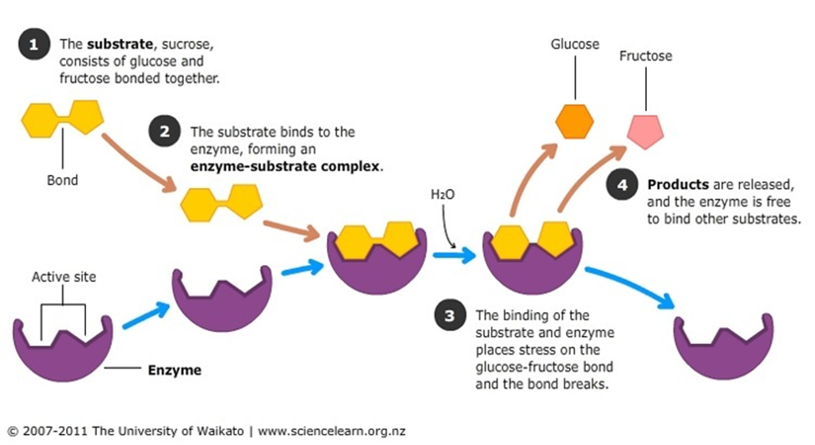The type of chemical reaction involved as the enzyme functions, for example, when sucrase acts on sucrose, it breaks it into a molecule of glucose and a molecule of fructose. This reaction involves adding a water molecule to break a chemical bond and so the enzyme is a hydrolase. All digestive enzymes belong to this hydrolase class.

Enzymes are classified according to the type of chemical reaction catalyzed. All digestive enzymes are hydrolases, whereas most of the enzymes involved in energy release for muscular contraction are oxidation-reduction enzymes such as oxidases, hydrogenases and dehydrogenases.

* Proteins are broken down by enzyme groups called proteases (split [proteins](https://en.wikipedia.org/wiki/Protein) into small [peptides](https://en.wikipedia.org/wiki/Peptides) and [amino acids](https://en.wikipedia.org/wiki/Amino_acid)).
* Lipids are broken down by enzyme groups called lipases (split [fat](https://en.wikipedia.org/wiki/Fat) into three [fatty acids](https://en.wikipedia.org/wiki/Fatty_acid) and a [glycerol](https://en.wikipedia.org/wiki/Glycerol) molecule).
* Nucleic acids are broken down by enzyme groups called nucleases (split DNA and RNA into nitrogen bases, phosphates, ribose and deoxyribose)
* Starches are broken down by enzyme groups called amylases (split [carbohydrates](https://en.wikipedia.org/wiki/Carbohydrate) such as [starch](https://en.wikipedia.org/wiki/Starch) and [sugars](https://en.wikipedia.org/wiki/Sugar) into [simple sugars](https://en.wikipedia.org/wiki/Monosaccharide) such as [glucose](https://en.wikipedia.org/wiki/Glucose)).



Digestive hormones are made by cells lining the stomach and small intestine. These hormones cross into the blood where they can affect other parts of the digestive system. Some of these hormones are listed below.

* Gastrin, which signals the secretion of gastric acid.
* Cholecystokinin, which signals the secretion of pancreatic enzymes.
* Secretin, which signals secretion of water and bicarbonate from the pancreas.
* Ghrelin, which signals when you are hungry.
* Gastric inhibitory polypeptide, which stops or decreases gastric secretion. It also causes the release of insulin in response to high blood glucose levels.